**2.wireless networking foundation (send digital)**

**1.Preparation**

1.You need to prepare two HelloBot cars.

2.You should learn about these blocks.

**Functions of wireless blocks:**

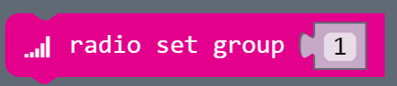

This block is to set the group ID of the wireless communication, and can only listen to a group ID at any time.

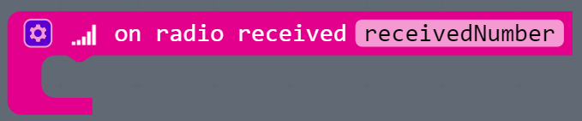

This block is to read the received digital packets. When the packet is received wirelessly, you can use this block.

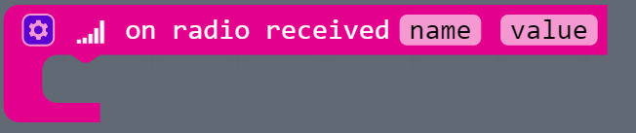

This block is to read the received name of variable and value of name. When the packet is received wirelessly, you can use this block.

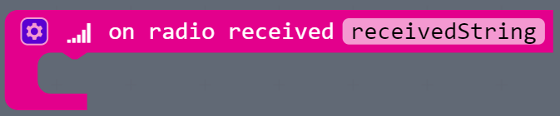

This block is to read the received character string packets. When the packet is received wirelessly, you can use this block.

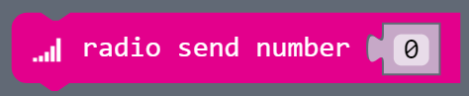

Send the number 0 wirelessly.

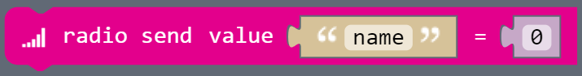

Send the name of variable wirelessly, name is 0.

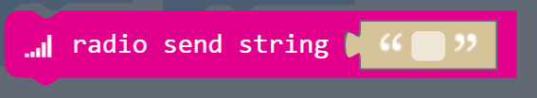

Send the character string wirelessly.

1. **Learning goals**

In this course, we will learn how to use the wireless networking function. We need to write a program to set the wireless communication group ID to 1. When the button A of one of HelloBot is pressed, it will send the number 0, if another car receive digital signal, it will display 0 on the dot matrix.

**3.Programming**

3.1 Programming online

**1) You should use the USB cable to connect the micro:bit to the computer, at this point, the computer will have a micro:bit U disk. You need to open it, click micro:bit website, then entered the micro:bit website** or you can enter the URL directly in your browser: http://microbit.org/

2) After entering the programming interface, you need to click Add package and copy the HelloBot package URL: https://github.com/lzty634158/HelloBot to the input field, click to confirm the add package. Then you can use the blocks of the HelloBot package.

3.2 Programming offline

1) You can double-click to use it. As shown in the following figure.

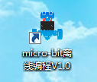

2) After entering the programming interface, you need to click Add package and copy the HelloBot package URL: https://github.com/lzty634158/HelloBot to the input field, click to confirm the add package. Then you can use the blocks of the HelloBot package.

**Note: The package only needs to be added once. If you have added packages in the previous lessons, this course does not need to be added repeatedly.**

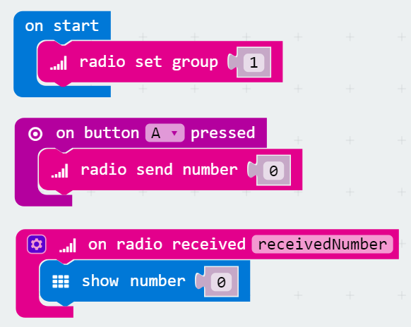

2-1 total program

The locations of blocks in the total program are shown in the following figure.

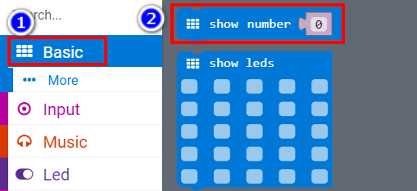

2-2

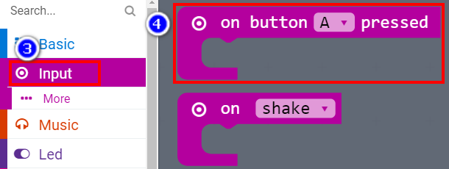

2-3

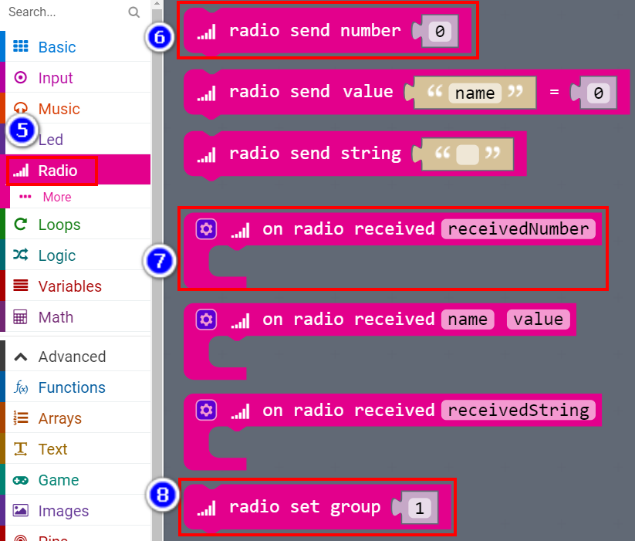

2-4

**4.Download programming**

You need to make sure that the micro:bit development board is connected to the computer. Then you should click on the download in the lower left corner as shown in P 2-5 to download the program to micro:bit.

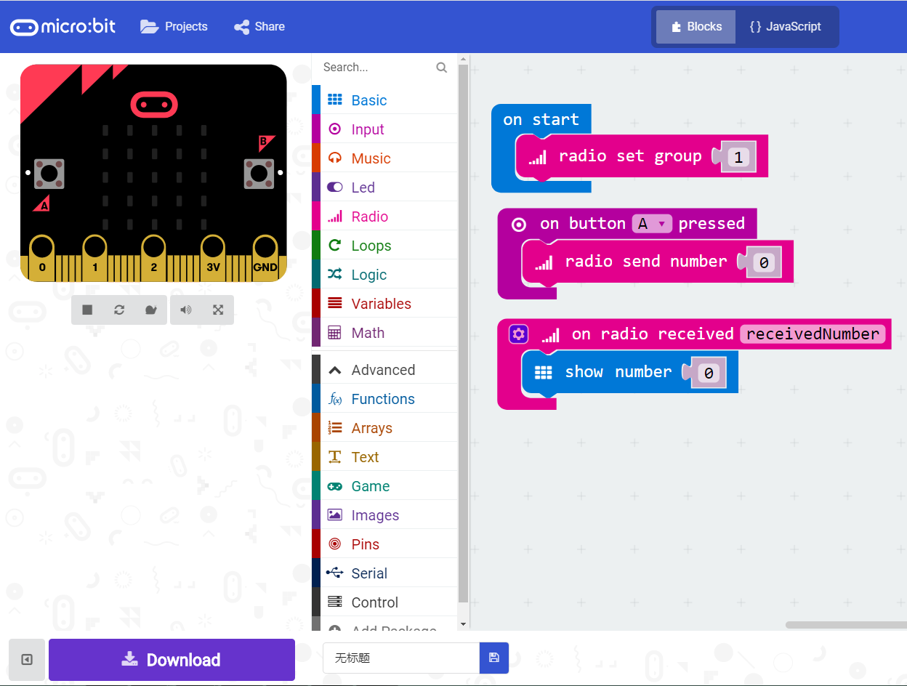

2-5

**5.Phenomenon**

You need to download code to two Micro:bit boards.

The experimental phenomenon of the program is that after starting up, two Micro:bit boards start networking, and their group ID is 1. When one of the Micro:bit board buttons A is pressed, which represents the sending of data signals. When another micro:bit board receives the wireless digital signal. The screen will display number 0.

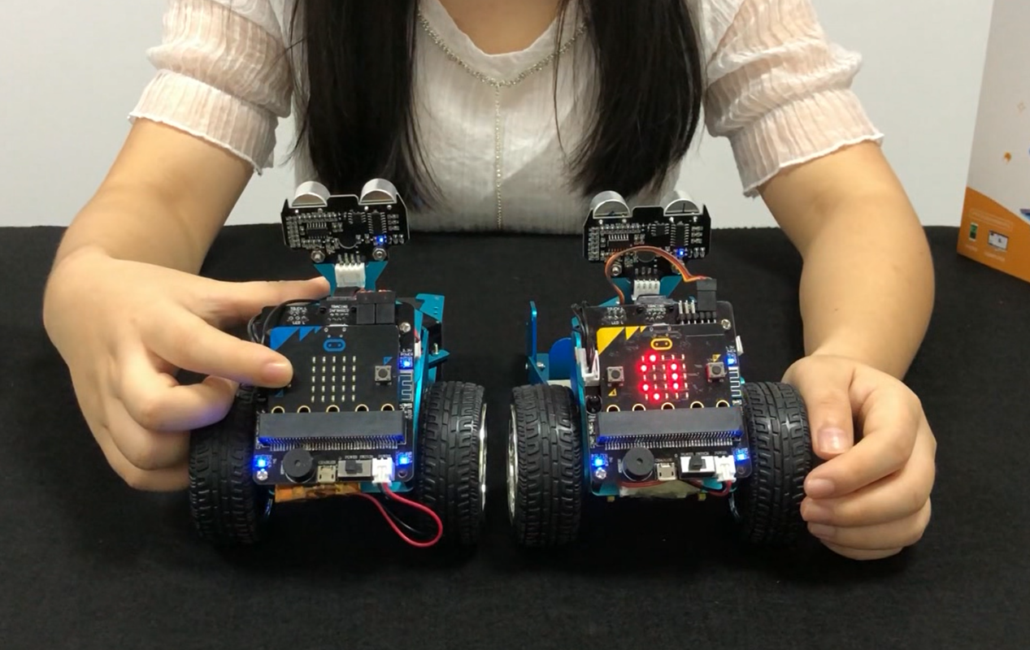

2-6 Press the A button of one of micro:bit, another micro:bit under the same group ID will display number “0” on the dot matrix

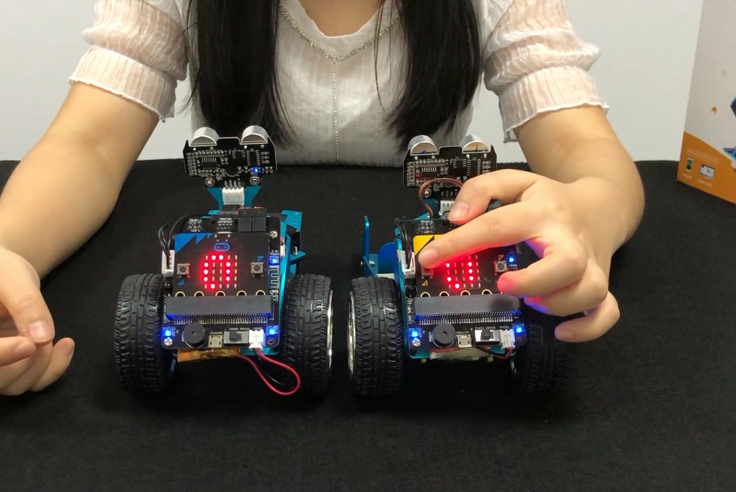

2-7 Press the A button of one of micro:bit, another micro:bit under the same group ID will display number “0” on the dot matrix